YEAR 10 SCIENCE (GENERAL)
PHYSICAL SCIENCES
REVISION - TEST 1

1. A person wants to go from Bunnings Belmont to Kmart Belmont. Use the scale on the map to work out:

(a) the distance between the two stores.

(b) the displacement of the person. Remember - this is in a straight line and you need to estimate the bearing (angle).

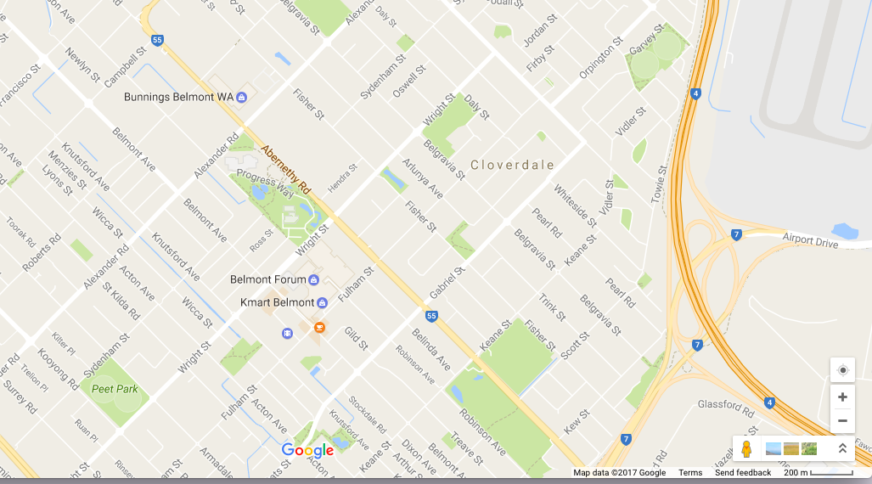

2. Complete the following table. Make sure you include the appropriate units for each quantity.

Distance travelled | Time taken | Average speed
100 m | 20 s
3000 m |  | 15 m/s
 | 15 s | 20 m/s
2000 m |  | 25 m/s

3. What is the speed of a sprinter who runs 100 m in 12.5 seconds?

4. What distance does a plane cover in 3.5 hours if it is flying at 550 kmh?

5. How long will it take a horse moving at 14 m/s to do one lap of an 840 m track?

